Machine Learning Lab Manual

Regulation : R22
Branch : B.TECH - CSE

Year & Semester : III Year/II Semester

INDEX
S.No | Name of the Experiment | Page No.
 | Write a python program to compute Central Tendency Measures: Mean, Median, Mode Measure of Dispersion: Variance, Standard Deviation | 1-3
 | Study of Python Basic Libraries such as Statistics, Math, Numpy and Scipy | 4-8
 | Study of Python Libraries for ML application such as Pandas and Matplotlib | 9-12
 | Write a Python program to implement Simple Linear Regression | 13-18
 | Implementation of Multiple Linear Regression for House Price Prediction using sklearn | 19-22
 | Implementation of Decision tree using sklearn and its parameter tuning | 23-27
 | Implementation of KNN using sklearn | 28-31
 | Implementation of Logistic Regression using sklearn | 32-36
 | Implementation of K-Means Clustering | 37-39
 | Performance analysis of Classification Algorithms on a specific dataset (Mini Project) | 40-47

- Write a python program to compute Central Tendency Measures: Mean, Median, Mode Measure of Dispersion: Variance, Standard Deviation.
Aim:
To write a Python program to compute the measures of central tendency (Mean, Median, Mode) and measures of dispersion (Variance and Standard Deviation).
Description:
Statistics plays an important role in Data Science and Machine Learning. It helps in understanding the nature, distribution, and spread of data. In this experiment, we compute Measures of Central Tendency and Measures of Dispersion using Python.

Measures of Central Tendency
These measures describe the central or average value of a dataset.
- Mean
The arithmetic average of all observations.
Formula:
Mean=∑XNMean = \frac{\sum X}{N}Mean=N∑X​
- Median
The middle value of the dataset when arranged in sorted order.
If the number of observations is even, median is the average of two middle values.
- Mode
The value that appears most frequently in the dataset.
These measures help us understand the central location of data.

Measures of Dispersion
These describe how spread out the data values are.
- Variance
It measures the average squared deviation from the mean.
Large variance → data widely spread.
- Standard Deviation
Square root of variance.
It indicates how much data deviates from the mean.

Importance
- Used in Data Analysis
- Used in Machine Learning preprocessing
- Helps detect outliers
- Used in research and surveys
Python provides a built-in statistics library to calculate these values easily.
Program:
import statistics
# Sample dataset
data = [10, 20, 20, 30, 40, 50]
# Central Tendency
mean = statistics.mean(data)
median = statistics.median(data)
mode = statistics.mode(data)
# Dispersion
variance = statistics.variance(data)
std_dev = statistics.stdev(data)
print("Mean:", mean)
print("Median:", median)
print("Mode:", mode)
print("Variance:", variance)
print("Standard Deviation:", std_dev)

Output:
Mean: 28.333333333333332
Median: 25.0
Mode: 20
Variance: 216.66666666666666
Standard Deviation: 14.719601443879744

Viva Questions:
- What is the difference between mean and median?
Mean is the average of all values.
Median is the middle value after arranging the data in order.
Mean is affected by extreme values, but median is not.
- When is median preferred over mean?
Median is preferred when the data has outliers or is not evenly distributed (skewed data)
- What is variance?
Variance is the measure of how far the data values are from the mean.
- Why do we use standard deviation instead of variance?
Standard deviation is easier to understand because it is in the same unit as the original data.
- What happens to variance if all values are same?
If all values are the same, variance becomes zero.

- Study of Python Basic Libraries such as Statistics, Math, Numpy and Scipy.
Aim:
To study and implement Python basic libraries such as Statistics, Math, NumPy, and SciPy for mathematical and statistical operations.
Description:
Python provides powerful built-in and external libraries that make mathematical, statistical, and scientific computations easier and faster. These libraries are widely used in Data Science, Machine Learning, Artificial Intelligence, Engineering, and Research fields. In this experiment, we study four important Python libraries: Statistics, Math, NumPy, and SciPy.
- Statistics Library
The statistics library is a built-in Python module used for performing basic statistical operations on numerical data. It helps in analyzing datasets by calculating measures of central tendency and dispersion.
Main functions include:
- mean() – calculates the average value
- median() – finds the middle value
- mode() – finds the most frequent value
- variance() – measures spread of data
- stdev() – calculates standard deviation
This library is useful when working with small datasets and basic data analysis tasks. It is simple to use and does not require installation since it is built into Python.
Applications:
- Data analysis
- Academic research
- Survey data processing
- Business statistics
- Math Library
The math library is also a built-in Python module used to perform mathematical operations. It provides functions for arithmetic, trigonometry, logarithms, exponentials, and more.
Important functions include:
- sqrt() – square root
- pow() – power
- exp() – exponential
- log() – logarithm
- sin(), cos(), tan() – trigonometric functions
- pi and e constants
The math library is mainly used in scientific calculations, engineering problems, and algorithm development.
Applications:
- Engineering calculations
- Scientific research
- Computer graphics
- Cryptography
- NumPy Library
NumPy (Numerical Python) is one of the most important libraries in Python for numerical computing. It is not built-in, so it must be installed separately. NumPy provides support for large multi-dimensional arrays and matrices, along with a large collection of mathematical functions to operate on them.
Main features:
- ndarray (N-dimensional array)
- Fast array operations
- Broadcasting
- Mathematical and statistical functions
- Linear algebra operations
NumPy is much faster than normal Python lists because it is implemented in C and optimized for performance.
Applications:
- Machine Learning
- Deep Learning
- Data Science
- Image processing
- Scientific simulations
- SciPy Library
SciPy (Scientific Python) is built on top of NumPy and provides advanced scientific computing tools. It includes modules for optimization, integration, interpolation, linear algebra, signal processing, and statistics.
Important modules:
- scipy.linalg – linear algebra
- scipy.optimize – optimization problems
- scipy.integrate – integration
- scipy.stats – advanced statistics
SciPy is mainly used when solving complex scientific and engineering problems that require high-level mathematical computations.
- Program using Statistics Library
import statistics
data = [10, 20, 30, 40, 50]
print("Mean:", statistics.mean(data))
print("Median:", statistics.median(data))
print("Variance:", statistics.variance(data))
print("Standard Deviation:", statistics.stdev(data))
Output:
Mean: 30
Median: 30
Variance: 250
Standard Deviation: 15.811388300841896
- Program using Math Library
import math
print("Square Root of 16:", math.sqrt(16))
print("Power 2^3:", math.pow(2, 3))
print("Exponential of 2:", math.exp(2))
print("Sine of 90 degrees:", math.sin(math.pi/2))
Output:
Square Root of 16: 4.0
Power 2^3: 8.0
Exponential of 2: 7.38905609893065
Sine of 90 degrees: 1.0
- Program using NumPy
import numpy as np
arr = np.array([1, 2, 3, 4, 5])
print("Array:", arr)
print("Mean:", np.mean(arr))
print("Sum:", np.sum(arr))
print("Squared Array:", arr ** 2)

Output:
Array: [1 2 3 4 5]
Mean: 3.0
Sum: 15
Squared Array: [ 1 4 9 16 25 ]
- Program using SciPy
from scipy.linalg import solve
A = [[2, 1], [1, 3]]
B = [5, 6]
solution = solve(A, B)
print("Solution:", solution)
Output:
Solution: [1.8 1.4]
Viva Questions:
- What is the use of statistics library?
It is used to calculate statistical measures like mean and median.
- What is the difference between NumPy and normal Python lists?
NumPy arrays are faster and support mathematical operations directly.
- What is SciPy built on?
SciPy is built on top of NumPy.
- Which library is used for mathematical functions like sqrt and sin?
The math library.
- Why is NumPy important in Machine Learning?
It handles large numerical data efficiently.
- What is the use of SciPy?
It is used for scientific and advanced mathematical computations.
- Study of Python Libraries for ML application such as Pandas and Matplotlib
Aim:
To study and implement Python libraries for Machine Learning applications such as Pandas and Matplotlib for data analysis and visualization.
Description:
In Machine Learning and Data Science, handling data and visualizing data are very important steps. Before building any model, we must clean, analyze, and understand the dataset. For this purpose, Python provides powerful libraries such as Pandas and Matplotlib.
- Pandas Library
Pandas is an open-source Python library used for data manipulation and data analysis. It provides flexible and easy-to-use data structures such as Series and DataFrame.
Main Data Structures:
• Series – One-dimensional labeled array
• DataFrame – Two-dimensional table with rows and columns
Important Features:
• Reading data from CSV, Excel, JSON files
• Handling missing values
• Filtering and sorting data
• Grouping and aggregation
• Statistical operations like mean, sum, count
• Data cleaning and preprocessing
Pandas is mainly used in the data preprocessing stage of Machine Learning. It helps convert raw data into structured format so that ML models can understand it.

- Matplotlib Library
Matplotlib is a Python library used for data visualization. It helps in creating graphs and charts to understand patterns and trends in data.
Common Types of Plots:
• Line plot
• Bar chart
• Scatter plot
• Histogram
• Pie chart
Program:
import pandas as pd
import matplotlib.pyplot as plt
# Create sample dataset
data = {
"Feature1": [1, 2, 3, 4],
"Feature2": [5, 6, 7, 8],
"Label": ['a', 'b', 'a', 'b']
}
# Create DataFrame
df = pd.DataFrame(data)
print("Dataset:")
print(df)
# Plot scatter graph
plt.figure()
for label in df["Label"].unique():
subset = df[df["Label"] == label]
plt.scatter(subset["Feature1"], subset["Feature2"], label=label)
plt.xlabel("Feature1")
plt.ylabel("Feature2")
plt.title("Feature1 vs Feature2")
plt.legend()
plt.show()
Output (Console):
Dataset:
Feature1 Feature2 Label
0 1 5 a
1 2 6 b
2 3 7 a
3 4 8 b
Output:
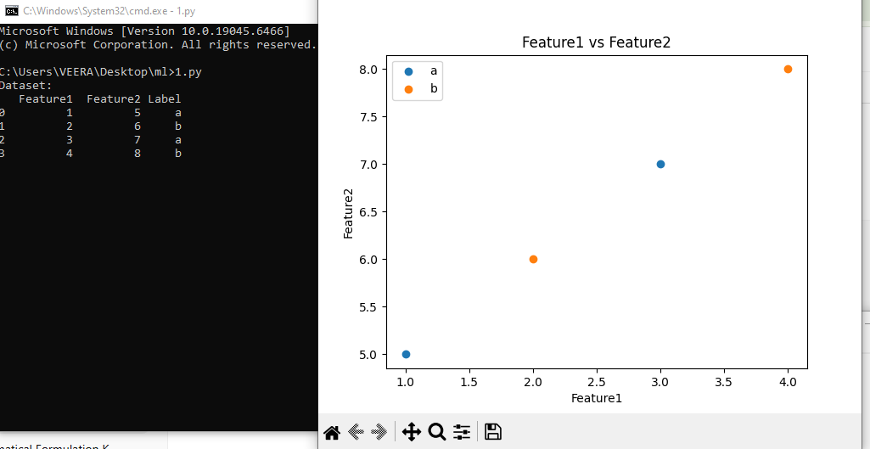

Viva Questions
- What is Pandas used for?
Pandas is used for data manipulation and analysis.
- What are the main data structures in Pandas?
Series and DataFrame.
- What is Matplotlib used for?
Matplotlib is used for data visualization.
- Why is visualization important in Machine Learning?
It helps understand patterns and relationships in data.
- What is a DataFrame?
A two-dimensional table with rows and columns.

- Write a Python program to implement Simple Linear Regression.
Aim:
To implement Simple Linear Regression using Python to predict a dependent variable based on a single independent variable.
Simple Linear Regression
Simple Linear Regression is a supervised machine learning algorithm used to model the relationship between one independent variable (X) and one dependent variable (Y).
It assumes that there exists a linear relationship between X and Y. That means when X changes, Y changes in a straight-line manner.
The general equation of Simple Linear Regression is:
y = mx + c
Where:
y = Dependent variable (output)
x = Independent variable (input)
m = Slope (coefficient)
c = Intercept (constant term)
The goal of the model is to find the best values of m and c such that the predicted values are as close as possible to the actual values.
Understanding Slope and Intercept
Slope (m):
The slope represents how much the dependent variable changes when the independent variable increases by one unit.
If:
m > 0 → positive relationship
m < 0 → negative relationship
m = 0 → no relationship
Intercept (c):
Intercept is the value of y when x = 0.
It is the point where the regression line crosses the y-axis.
Least Square Method
The Least Square Method is used to find the best-fitting straight line for the given data points.
The best-fit line minimizes the sum of the squared differences between actual values and predicted values.
Error = Actual value – Predicted value
e = y – ŷ
To avoid negative values canceling out positive ones, we square the errors:
Squared Error = (y – ŷ)²
The objective is to minimize:
Σ (y – ŷ)²
This is called the Sum of Squared Errors (SSE).
Formulas for Slope (m) and Intercept (c)
For n data points:
Slope (m) formula:
m = [ nΣ(xy) – Σx Σy ] / [ nΣ(x²) – (Σx)² ]
Intercept (c) formula:
c = ( Σy – mΣx ) / n
Where:
Σx = sum of all x values
Σy = sum of all y values
Σxy = sum of product of x and y
Σx² = sum of square of x values
n = number of observations
These formulas are derived by minimizing the squared error function using calculus.
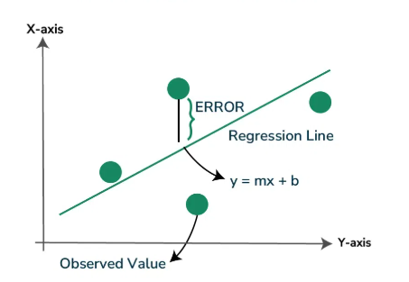
Program:
import pandas as pd
import matplotlib.pyplot as plt
from sklearn import linear_model
from sklearn.model_selection import train_test_split
#Read Datasert
df=pd.read_csv(r"C:\Users\Tabeen Fatima\Downloads\Salary_Data[1].csv")
#check for missing value
print(df.isnull().sum())
#drop null values
df2=df.dropna()
#Extract x feature and y target for dataset
x=df2[['Years of Experience']].values
print(x)
y=df2['Salary'].values
print(y)
# splitting the dataset
X_train,X_test,Y_train,Y_test= train_test_split(x,y,test_size=1/3,random_state=0)
# fitting the regression model
model=linear_model.LinearRegression()
model.fit(X_train,Y_train)
predicted_value=model.predict([[22.5]])
print("predicted value for 22.5 years of experience:",predicted_value)
# visualizing the results
plt.title("Years of Experience vs Salary (Training Data)")
plt.xlabel("Years of Experience")
plt.ylabel("Salary")
plt.scatter(X_train,Y_train,color='g',marker='*')
plt.plot(X_train,model.predict(X_train),color='r',linewidth=2,label='Regeression Line')
plt.legend()
plt.show()
plt.title("Years of Experience vs Salary (Test Data)")
plt.xlabel("Years of Experience")
plt.ylabel("Salary")
plt.scatter(X_test,Y_test,color='g',marker='*')
plt.plot(X_test,model.predict(X_test),color='r',linewidth=2,label='Regeression Line')
plt.legend()
plt.show()
Output: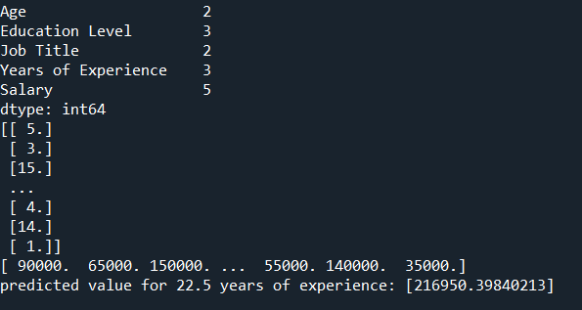
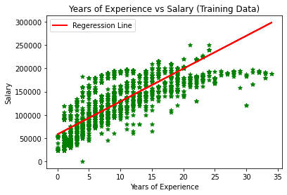
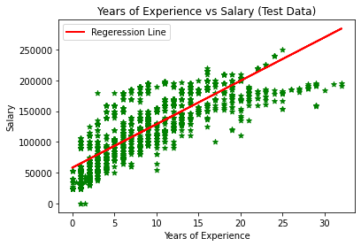

Viva Questions:
- What is Simple Linear Regression?
It is a supervised algorithm that models relationship between one independent and one dependent variable.
- What is the equation of linear regression?
Y = b0 + b1X
- What is slope?
Slope shows how much Y changes when X increases by one unit.
- What is intercept?
Intercept is the value of Y when X is zero.

- Implementation of Multiple Linear Regression for House Price Prediction using sklearn
Aim:
To implement Multiple Linear Regression using sklearn for predicting house prices based on multiple features and evaluate model performance.
Description:
Multiple Linear Regression:Multiple linear regression is a regression model that estimates the relationship between a quantitative dependent variable and two or more independent variables using a straight line.
Mean Squared Error
Mean squared error (MSE) is a metric used to measure the average squared difference between the predicted values and the actual values in the dataset. It is calculated by taking the average of the squared residuals, where the residual is the difference between predicted value and the actual value for each data point. The MSE value provides a way to analyse the accuracy of the model.
Mean Absolute Error
Mean Absolute Error calculates the average difference between the calculated values and actual values.
R2 Score
R-Squared (R² or the coefficient of determination) is a statistical measure in a regression model that determines the proportion of variance in the dependent variable that can be explained by the independent variable.

Program:
# Import necessary libraries
import pandas as pd
import numpy as np
import matplotlib.pyplot as plt
from sklearn.model_selection import train_test_split
from sklearn.linear_model import LinearRegression
from sklearn.metrics import mean_absolute_error, mean_squared_error, r2_score
# Load dataset (Example Data)
data = {
'square_feet': [1500, 1800, 2400, 3000, 3500, 4000, 4500, 5000, 5500, 6000],
'num_bedrooms': [3, 4, 3, 5, 4, 6, 5, 7, 6, 8],
'num_bathrooms': [2, 2, 3, 3, 4, 4, 5, 5, 6, 6],
'year_built': [2000, 2005, 2010, 2015, 2020, 1995, 1985, 2018, 2012, 2008],
'price': [300000, 350000, 450000, 500000, 600000, 650000, 700000, 800000, 850000, 900000]
}
# Create DataFrame
df = pd.DataFrame(data)
# Display the first few rows of the dataset
print("Dataset Sample:\n", df.head())
# Select independent variables (features) and dependent variable (target)
X = df[['square_feet', 'num_bedrooms', 'num_bathrooms', 'year_built']] # Features
y = df['price'] # Target variable
# Split dataset into training (80%) and testing (20%)
X_train, X_test, y_train, y_test = train_test_split(X, y, test_size=0.2, random_state=42)
# Initialize and train the Linear Regression model
model = LinearRegression()
model.fit(X_train, y_train)
# Predict house prices for the test set
y_pred = model.predict(X_test)
# Model Evaluation
mae = mean_absolute_error(y_test, y_pred)
mse = mean_squared_error(y_test, y_pred)
rmse = np.sqrt(mse)
r2 = r2_score(y_test, y_pred)
# Print model coefficients
print("\nModel Coefficients:")
print("Intercept:", model.intercept_)
print("Feature Coefficients:", model.coef_)
# Print performance metrics
print("\nModel Performance:")
print(f"Mean Absolute Error (MAE): {mae:.2f}")
print(f"Mean Squared Error (MSE): {mse:.2f}")
print(f"Root Mean Squared Error (RMSE): {rmse:.2f}")
print(f"R-squared (RÂ²): {r2:.2f}")
# Visualization: Actual vs Predicted Prices
plt.scatter(y_test, y_pred, color='blue', alpha=0.5)
plt.xlabel("Actual Prices")
plt.ylabel("Predicted Prices")
plt.title("Actual vs Predicted House Prices")
plt.plot([min(y_test), max(y_test)], [min(y_test), max(y_test)], color='red', linestyle='dashed')
plt.show()
Output:
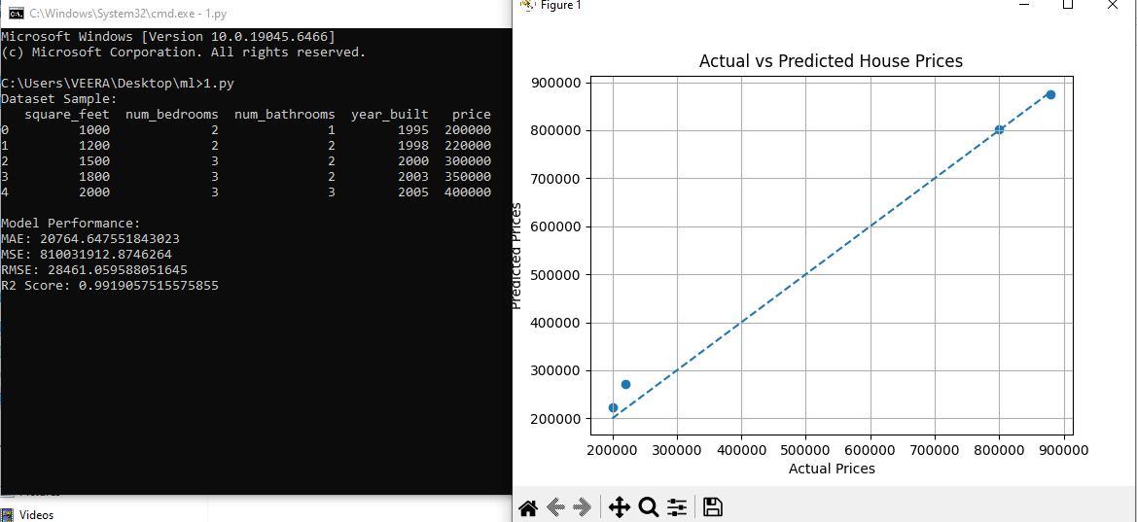
Viva Questions:
  - What is Multiple Linear Regression?
Multiple Linear Regression is a regression model that predicts a dependent variable using two or more independent variables.
  - What is the equation of Multiple Linear Regression?
y = b0 + b1x1 + b2x2 + b3x3 + ... + bnxn
Where b0 is intercept and b1, b2, etc. are coefficients.
  - What is the difference between Simple and Multiple Linear Regression?
Simple Linear Regression uses one independent variable, while Multiple Linear Regression uses two or more independent variables.
  - What is Mean Absolute Error (MAE)?
MAE is the average of absolute differences between actual and predicted values.
  - What is Mean Squared Error (MSE)?
MSE is the average of squared differences between actual and predicted.
- Implementation of Decision tree using sklearn and its parameter tuning
Aim:
To implement Decision Tree algorithm using sklearn and perform parameter tuning to improve model accuracy.
Description:
Decision Tree:
A decision tree is a non-parametric supervised learning algorithm, which is utilized for both classification and regression tasks. It has a hierarchical, tree structure, which consists of a root node, branches, internal nodes and leaf nodes.It has a hierarchical tree structure starts with one main question at the top called a node which further branches out into different possible outcomes where:
- Root Node is the starting point that represents the entire dataset.
- Branches: These are the lines that connect nodes. It shows the flow from one decision to another.
- Internal Nodes are Points where decisions are made based on the input features.
- Leaf Nodes: These are the terminal nodes at the end of branches that represent final outcomes or predictions
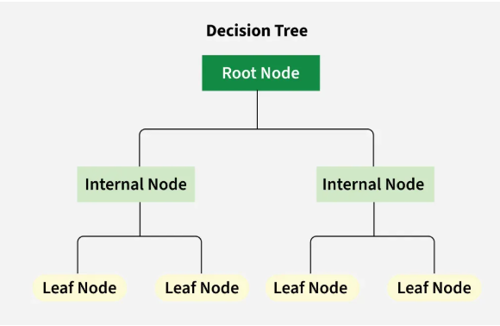

Precision:
It refers to the proportion of correct positive predictions (True Positives) out of all the positive predictions made by the model (True Positives + False Positives). It is a measure of the accuracy of the positive predictions.
The formula for Precision is:

2. Recall (Sensitivity or True Positive Rate):
It is also known as Sensitivity or True Positive Rate where we measures the proportion of actual positive instances that were correctly identified by the model. It is the ratio of True Positives to the total actual positives (True Positives + False Negatives).
The formula for Recall is:

F1 Score:
- It combines precision and recall into a single value.
- The harmonic mean of precision and recall, providing a single metric that balances both.
- Formula: F1 Score = 2 * (Precision * Recall) / (Precision + Recall)
Program:
import pandas as pd
import matplotlib.pyplot as plt
from sklearn.datasets import load_iris
iris=load_iris()
iris
X=iris.data
print(X)
Y=iris.target
print(Y)
from sklearn.model_selection import train_test_split
X_train,X_test,Y_train,Y_test=train_test_split(X,Y,test_size=0.2,random_state=42)
from sklearn.tree import DecisionTreeClassifier
treemodel=DecisionTreeClassifier(max_depth=2)
treemodel.fit(X_train,Y_train)
from sklearn import tree
plt.figure(figsize=(5,5))
tree.plot_tree(treemodel,filled=True)
y_predict=treemodel.predict(X_test)
print(y_predict)
from sklearn.metrics import accuracy_score,classification_report
score=accuracy_score(y_predict,Y_test)
print("score",score)
print(classification_report(y_predict,Y_test))
Output:
[[5.1 3.5 1.4 0.2]
[4.9 3. 1.4 0.2]
[4.7 3.2 1.3 0.2]
[4.6 3.1 1.5 0.2]
[5. 3.6 1.4 0.2]
[5.4 3.9 1.7 0.4]
[6.9 3.1 5.1 2.3]
[5.8 2.7 5.1 1.9]
[6.8 3.2 5.9 2.3]
[6.7 3.3 5.7 2.5]
[6.7 3. 5.2 2.3]
[6.3 2.5 5. 1.9]
[6.5 3. 5.2 2. ]
[6.2 3.4 5.4 2.3]
[5.9 3. 5.1 1.8]]
[0 0 0 0 0 0 0 0 0 0 0 0 0 0 0 0 0 0 0 0 0 0 0 0 0 0 0 0 0 0 0 0 0 0 0 0 0
0 0 0 0 0 0 0 0 0 0 0 0 0 1 1 1 1 1 1 1 1 1 1 1 1 1 1 1 1 1 1 1 1 1 1 1 1
1 1 1 1 1 1 1 1 1 1 1 1 1 1 1 1 1 1 1 1 1 1 1 1 1 1 2 2 2 2 2 2 2 2 2 2 2
2 2 2 2 2 2 2 2 2 2 2 2 2 2 2 2 2 2 2 2 2 2 2 2 2 2 2 2 2 2 2 2 2 2 2 2 2
2 2]
[1 0 2 1 2 0 1 2 1 1 2 0 0 0 0 1 2 1 1 2 0 2 0 2 2 2 2 2 0 0]
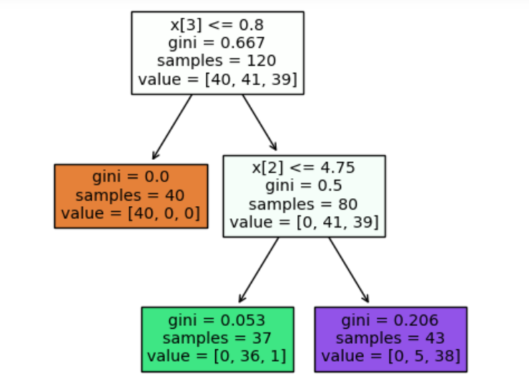
score 0.9666666666666667
precision recall f1-score support
0 1.00 1.00 1.00 10
1 0.89 1.00 0.94 8
2 1.00 0.92 0.96 12

accuracy 0.97 30
macro avg 0.96 0.97 0.97 30
weighted avg 0.97 0.97 0.97 30

Viva Questions:
  - What is a Decision Tree?
A Decision Tree is a supervised machine learning algorithm used for classification and regression. It splits the data into branches based on feature values to make predictions.
  - What are the main components of a Decision Tree?
Root node, internal nodes, branches, and leaf nodes.
  - What is entropy in a Decision Tree?
Entropy measures the impurity or randomness in the data. Lower entropy means more pure data.
  - What is information gain?
Information gain is the reduction in entropy after splitting the dataset. The feature with highest information gain is selected for splitting.
  - What is Gini Index?
Gini Index is another measure of impurity used in Decision Trees. Lower Gini value indicates better split.
  - What is parameter tuning in Decision Tree?
Parameter tuning means adjusting parameters like max_depth, min_samples_split, and criterion to improve model performance and avoid overfitting.

- Implementation of KNN using sklearn
Aim:
To implement K-Nearest Neighbors (KNN) algorithm using sklearn for classification problems.
Description:
K-Nearest Neighbour is a simple, supervised machine learning (ML) algorithm that can be used for classification . is based on the idea that the observations closest to a given data point are the most "similar" observations in a data set, and we can therefore classify unforeseen points based on the values of the closest existing points. By choosing K, the user can select the number of nearby observations to use in the algorithm.
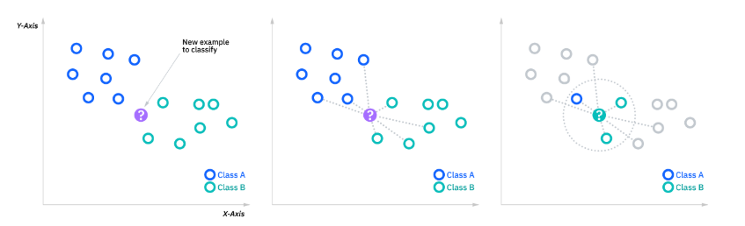
Program:
import pandas as pd
from sklearn.datasets import load_iris
iris=load_iris()
iris
X=iris.data
print(X)
Y=iris.target
print(Y)
from sklearn.model_selection import train_test_split
X_train, X_test, y_train, y_test = train_test_split(X, Y, test_size=0.20)
from sklearn.preprocessing import StandardScaler
scaler = StandardScaler()
scaler.fit(X_train)
X_train = scaler.transform(X_train)
X_test = scaler.transform(X_test)
from sklearn.neighbors import KNeighborsClassifier
classifier = KNeighborsClassifier(n_neighbors=5)
classifier.fit(X_train, y_train)
y_pred = classifier.predict(X_test)
from sklearn.metrics import classification_report, confusion_matrix
print(confusion_matrix(y_test, y_pred))
print(classification_report(y_test, y_pred))

Output:
[6.3 2.7 4.9 1.8]
[6.7 3.3 5.7 2.1]
[7.2 3.2 6. 1.8]
[6.2 2.8 4.8 1.8]
[6.1 3. 4.9 1.8]
[6.4 2.8 5.6 2.1]
[7.2 3. 5.8 1.6]
[7.4 2.8 6.1 1.9]
[7.9 3.8 6.4 2. ]
[6.4 2.8 5.6 2.2]
[6.3 2.8 5.1 1.5]
[6.1 2.6 5.6 1.4]
[7.7 3. 6.1 2.3]
[6.3 3.4 5.6 2.4]
[6.4 3.1 5.5 1.8]
[6. 3. 4.8 1.8]
[6.9 3.1 5.4 2.1]
[6.7 3.1 5.6 2.4]
[6.9 3.1 5.1 2.3]
[5.8 2.7 5.1 1.9]
[6.8 3.2 5.9 2.3]
[6.7 3.3 5.7 2.5]
[6.7 3. 5.2 2.3]
[6.3 2.5 5. 1.9]
[6.5 3. 5.2 2. ]
[6.2 3.4 5.4 2.3]
[5.9 3. 5.1 1.8]]
[0 0 0 0 0 0 0 0 0 0 0 0 0 0 0 0 0 0 0 0 0 0 0 0 0 0 0 0 0 0 0 0 0 0 0 0 0
0 0 0 0 0 0 0 0 0 0 0 0 0 1 1 1 1 1 1 1 1 1 1 1 1 1 1 1 1 1 1 1 1 1 1 1 1
1 1 1 1 1 1 1 1 1 1 1 1 1 1 1 1 1 1 1 1 1 1 1 1 1 1 2 2 2 2 2 2 2 2 2 2 2
2 2 2 2 2 2 2 2 2 2 2 2 2 2 2 2 2 2 2 2 2 2 2 2 2 2 2 2 2 2 2 2 2 2 2 2 2
2 2]
[[13 0 0]
[ 0 8 1]
[ 0 0 8]]
precision recall f1-score support

0 1.00 1.00 1.00 13
1 1.00 0.89 0.94 9
2 0.89 1.00 0.94 8

accuracy 0.97 30
macro avg 0.96 0.96 0.96 30
weighted avg 0.97 0.97 0.97 30

Viva Questions:
  - What is Logistic Regression?
Logistic Regression is a supervised machine learning algorithm used for classification problems.
  - Is Logistic Regression used for regression or classification?
It is used for classification.
  - What type of output does Logistic Regression give?
It gives probability values between 0 and 1.
  - What is the main function used in Logistic Regression?
The sigmoid function.
  - What is the sigmoid function?
Sigmoid function converts any real value into a value between 0 and 1.
Formula:
σ(z) = 1 / (1 + e^(-z))
  - What is the difference between Linear Regression and Logistic Regression?
Linear Regression predicts continuous values.
Logistic Regression predicts categorical values.

- Implementation of Logistic Regression using sklearn
Aim:
To implement Logistic Regression using the sklearn library and evaluate its performance on a given dataset.

REQUIREMENTS:

Hardware:
- A computer with at least 4GB RAM
- Processor: Intel i3 or above

Software:
- Python 3.x
- scikit-learn (Machine Learning Library)
- numpy, pandas (Data Processing)
- matplotlib (Visualization)
- Jupyter Notebook or any Python IDE (PyCharm, VS Code, etc.)
Descriptions:
Logistic Regression is a supervised learning algorithm used for classification problems. It predicts the probability of a class using the sigmoid function:
P(y = 1 | X) = 1 / (1 + e^-(β0 + β1X))
Where:
• X represents the input features.
• β0 and β1 are the model coefficients.
• The output is a probability value between 0 and 1.
Import required libraries
Load the dataset (Iris dataset)
Preprocess the data (Standardization and Train-Test Split)
Train the Logistic Regression model
Make predictions
Evaluate the model (Accuracy, Confusion Matrix, Classification Report)
Program:
# Import required libraries
import numpy as np
import pandas as pd
import matplotlib.pyplot as plt
import seaborn as sns
from sklearn.datasets import load_iris
from sklearn.model_selection import train_test_split
from sklearn.preprocessing import StandardScaler
from sklearn.linear_model import LogisticRegression
from sklearn.metrics import accuracy_score, confusion_matrix, classification_report
# Load Iris dataset
iris = load_iris()
X = iris.data
y = iris.target
# Split dataset into training and testing
X_train, X_test, y_train, y_test = train_test_split(X, y, test_size=0.3, random_state=42)
# Standardize the data
scaler = StandardScaler()
X_train = scaler.fit_transform(X_train)
X_test = scaler.transform(X_test)
# Train Logistic Regression model
model = LogisticRegression()
model.fit(X_train, y_train)
# Make predictions
ypred = model.predict(X_test)
# Evaluate the model
accuracy = accuracy_score(y_test, y_pred)
cm = confusion_matrix(y_test, y_pred)
print("Accuracy:", accuracy)
print("\nConfusion Matrix:\n", cm)
print("\nClassification Report:\n", classification_report(y_test, y_pred))
# Visualize Confusion Matrix
plt.figure()
sns.heatmap(cm, annot=True, fmt='d')
plt.xlabel("Predicted")
plt.ylabel("Actual")
plt.title("Confusion Matrix")
plt.show()

Output:
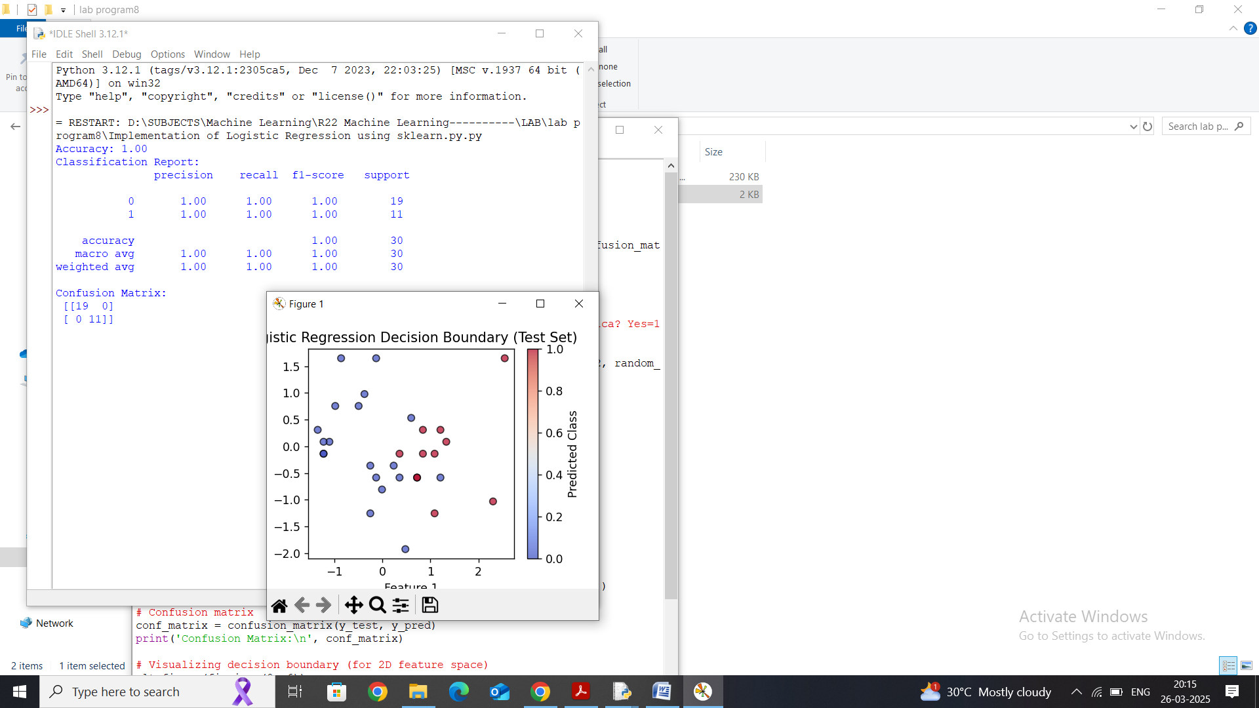

Viva Questions:
  - What is Logistic Regression?
Logistic Regression is a supervised learning algorithm used for classification problems.
  - Why is it called regression if it is used for classification?
Because it uses a regression equation to calculate probabilities.
  - What function is used in Logistic Regression?
Sigmoid function.
  - What is the range of sigmoid function?
The output range is between 0 and 1.
  - What is a confusion matrix?
It is a table used to evaluate classification performance.
  - What are evaluation metrics used in Logistic Regression?
Accuracy, Precision, Recall, F1-score.
  - What is the difference between Linear and Logistic Regression?
Linear Regression predicts continuous values.
Logistic Regression predicts categorical values.

- Implementation of K-Means Clustering

Aim:
To implement K-Means Clustering using the sklearn library and visualize the results on a given dataset.
REQUIREMENTS:

Hardware:
- A computer with at least 4GB RAM
- Processor: Intel i3 or above

Software:
- Python 3.x
- scikit-learn (Machine Learning Library)
- numpy, pandas (Data Processing)
- matplotlib, seaborn (Visualization)
- Jupyter Notebook or any Python IDE (PyCharm, VS Code, etc.)

THEORY:
K-Means Clustering is an unsupervised machine learning algorithm used for clustering data into K groups. It works by:
- Selecting K random centroids.
- Assigning each data point to the nearest centroid (forming clusters).
- Recomputing centroids based on the mean of assigned points.
- Repeating until centroids do not change significantly.

Mathematical Formulation:
J=∑i=1K∑j=1n∥xj(i)−ci∥2J = \sum_{i=1}^{K} \sum_{j=1}^{n} \left\| x_j^{(i)} - c_i \right\|^2J=i=1∑K​j=1∑n​​xj(i)​−ci​​2
where:
- K = number of clusters
- xᵢⱼ⁽ⁱ⁾ = data point assigned to cluster i
- cᵢ = centroid of cluster i

4. PROCEDURE:
- Import necessary libraries
- Load dataset (Iris dataset)
- Preprocess data (Standardization if necessary)
- Apply K-Means Clustering
- Evaluate and visualize clusters
- Analyze results
Output:
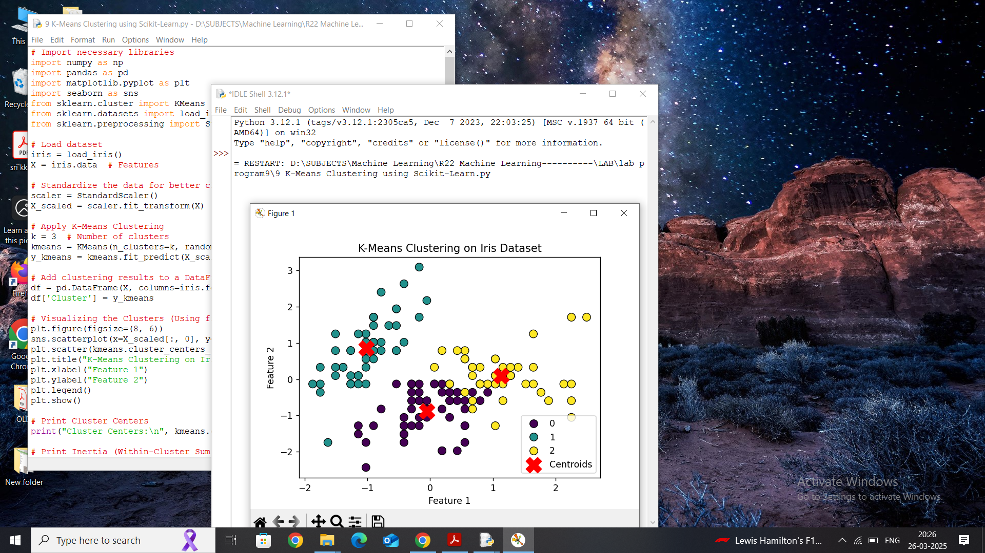
Viva Questions:

- What is K-Means Clustering?
K-Means is an unsupervised learning algorithm used to group data into clusters based on similarity.
- Is K-Means supervised or unsupervised?
It is an unsupervised learning algorithm.
- What does K represent in K-Means?
K represents the number of clusters.
- How does K-Means algorithm work?
It selects K centroids, assigns data points to nearest centroid, updates centroids, and repeats until convergence.
- What is a centroid?
A centroid is the center point of a cluster.

10. Performance analysis of Classification Algorithms on a specific dataset (Mini Project)

1. Aim
To compare and analyze the performance of different classification algorithms on a selected dataset based on evaluation metrics such as accuracy, precision, recall, F1-score, and ROC-AUC.
- Requirements

Hardware:
- Computer with 4GB RAM or more
- Intel i3 or higher processor

Software:
- Python 3.x
- scikit-learn (Machine Learning Library)
- numpy, pandas (Data Processing)
- matplotlib, seaborn (Visualization)
- Jupyter Notebook / Google Colab / Any Python IDE (PyCharm, VS Code)
- Dataset Selection
- Use a dataset from:
  - Kaggle (e.g., Titanic, Heart Disease, MNIST)
  - UCI Machine Learning Repository
  - Scikit-Learn built-in datasets (e.g., Iris, Breast Cancer)
Example: Breast Cancer Dataset (sklearn.datasets.load_breast_cancer)
- Classification Algorithms
The following algorithms will be analyzed:
- Logistic Regression
- K-Nearest Neighbors (KNN)
- Decision Tree
- Random Forest
- Support Vector Machine (SVM)
- Naive Bayes
- Methodology
- Load and preprocess the dataset (handle missing values, feature scaling if needed).
- Split into training and testing sets.
- Train multiple classification models.
- Evaluate each model using:
  - Accuracy
  - Precision, Recall, F1-Score
  - Confusion Matrix
  - ROC-AUC Curve
- Compare results and determine the best-performing model.
- Program
# ===============================
# 1. Import Required Libraries
# ===============================
import numpy as np
import pandas as pd
import matplotlib.pyplot as plt
import seaborn as sns
from sklearn.datasets import load_breast_cancer
from sklearn.model_selection import train_test_split
from sklearn.preprocessing import StandardScaler
from sklearn.linear_model import LogisticRegression
from sklearn.neighbors import KNeighborsClassifier
from sklearn.tree import DecisionTreeClassifier
from sklearn.ensemble import RandomForestClassifier
from sklearn.svm import SVC
from sklearn.naive_bayes import GaussianNB
from sklearn.metrics import accuracy_score, precision_score, recall_score, f1_score
from sklearn.metrics import confusion_matrix, roc_auc_score, roc_curve
# ===============================
# 2. Load Dataset
# ===============================
data = load_breast_cancer()
X = data.data
y = data.target
# Convert to DataFrame (optional)
df = pd.DataFrame(X, columns=data.feature_names)
df['target'] = y
# ===============================
# 3. Train-Test Split
# ===============================
X_train, X_test, y_train, y_test = train_test_split(
X, y, test_size=0.2, random_state=42
)
# ===============================
# 4. Feature Scaling
# ===============================
scaler = StandardScaler()
X_train = scaler.fit_transform(X_train)
X_test = scaler.transform(X_test)
# ===============================
# 5. Define Models
# ===============================
models = {
"Logistic Regression": LogisticRegression(max_iter=5000),
"KNN": KNeighborsClassifier(),
"Decision Tree": DecisionTreeClassifier(),
"Random Forest": RandomForestClassifier(),
"SVM": SVC(probability=True),
"Naive Bayes": GaussianNB()
}
# ===============================
# 6. Train and Evaluate Models
# ===============================
results = []
plt.figure(figsize=(8,6))
for name, model in models.items():
# Train
model.fit(X_train, y_train)
# Predict
y_pred = model.predict(X_test)

# Probability (for ROC-AUC)
if hasattr(model, "predict_proba"):
y_prob = model.predict_proba(X_test)[:,1]
else:
y_prob = model.decision_function(X_test)
# Metrics
acc = accuracy_score(y_test, y_pred)
prec = precision_score(y_test, y_pred)
rec = recall_score(y_test, y_pred)
f1 = f1_score(y_test, y_pred)
roc_auc = roc_auc_score(y_test, y_prob)
results.append([name, acc, prec, rec, f1, roc_auc])

# ROC Curve
fpr, tpr, _ = roc_curve(y_test, y_prob)
plt.plot(fpr, tpr, label=name)
# ROC Plot
plt.plot([0,1],[0,1],'k--')
plt.xlabel("False Positive Rate")
plt.ylabel("True Positive Rate")
plt.title("ROC Curve Comparison")
plt.legend()
plt.show()
# ===============================
# 7. Create Results Table
# ===============================
results_df = pd.DataFrame(results, columns=[
"Model", "Accuracy", "Precision", "Recall", "F1-Score", "ROC-AUC"
])

print("\nPerformance Comparison Table:\n")
print(results_df)
# ===============================
# 8. Bar Plot Comparison
# ===============================
results_df.set_index("Model")[["Accuracy","Precision","Recall","F1-Score","ROC-AUC"]].plot(
kind="bar", figsize=(10,6)
)
plt.title("Model Performance Comparison")
plt.ylabel("Score")
plt.xticks(rotation=45)
plt.legend(loc="lower right")
plt.tight_layout()
plt.show()
# ===============================
# 9. Confusion Matrix (Example: Best Model)
# ===============================
best_model_name = results_df.sort_values(by="Accuracy", ascending=False).iloc[0]["Model"]
best_model = models[best_model_name]
y_pred_best = best_model.predict(X_test)
cm = confusion_matrix(y_test, y_pred_best)
plt.figure(figsize=(5,4))
sns.heatmap(cm, annot=True, fmt='d', cmap="Blues")
plt.title(f"Confusion Matrix - {best_model_name}")
plt.xlabel("Predicted")
plt.ylabel("Actual")
plt.show()

7. Expected Output
- Table of performance metrics (Accuracy, Precision, Recall, F1-score, ROC-AUC).
- Bar plot visualization comparing different algorithms.
- Confusion Matrices for selected models.

8. Results & Conclusion
- Identify which classification algorithm performs the best for the dataset.
- Discuss the trade-offs between different models.
Output:
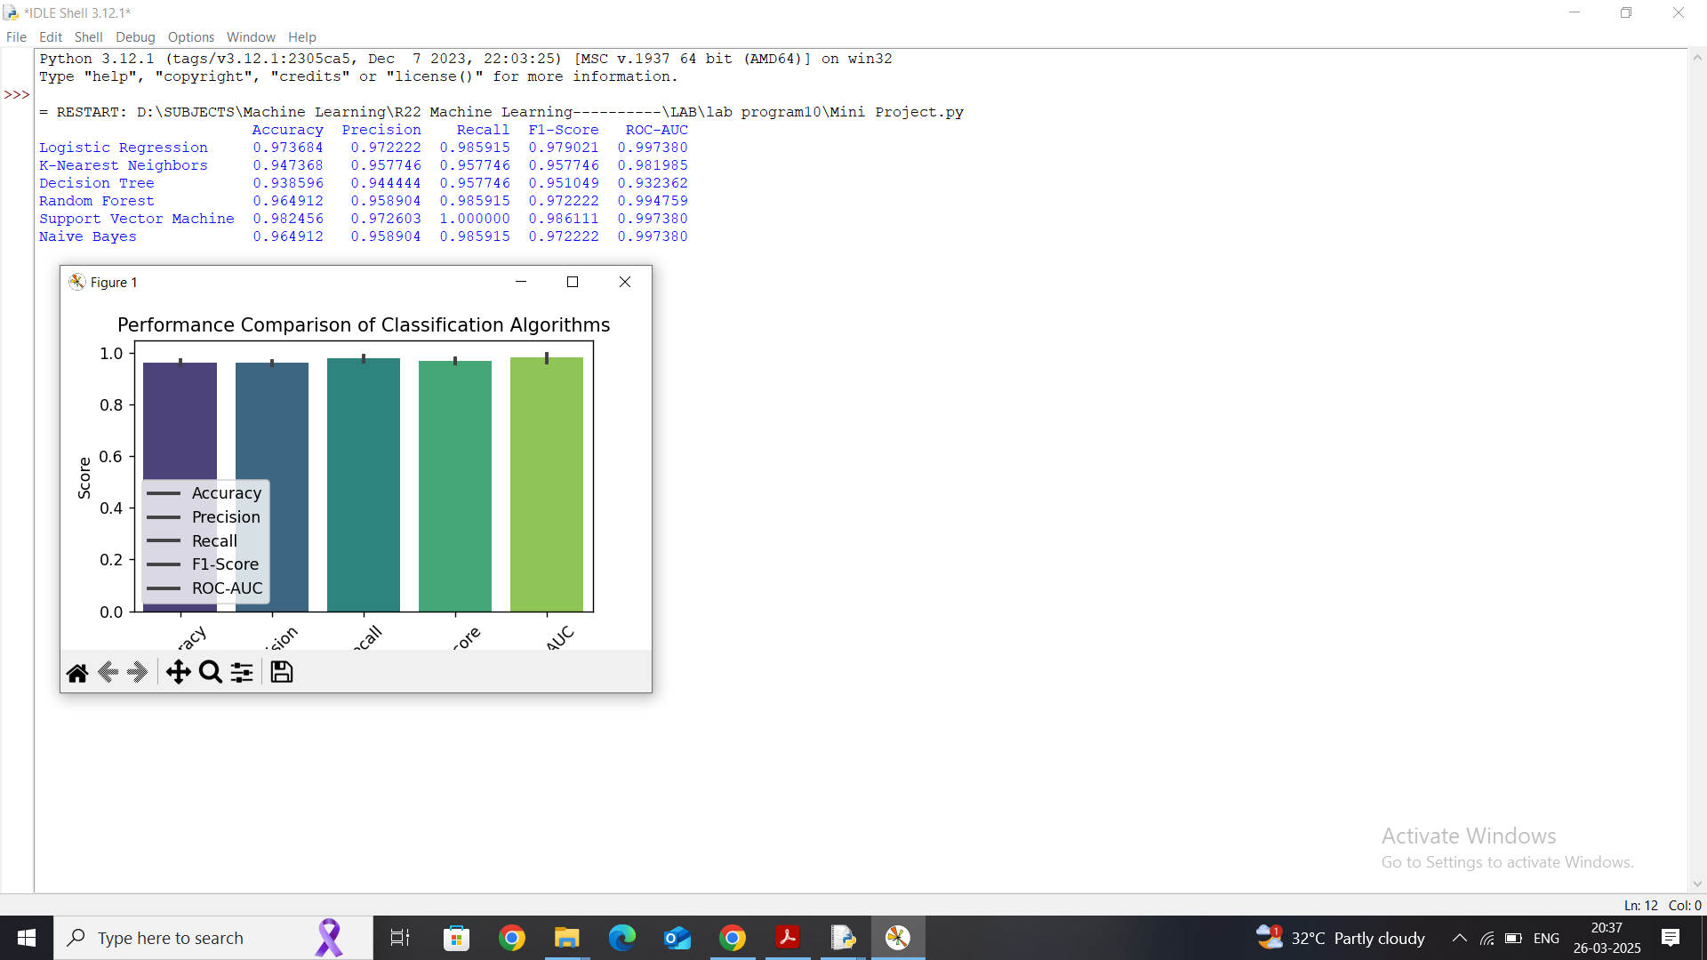

Viva Questions:
  - What is performance analysis?
It is the process of evaluating how well a model works.
  - What is accuracy?
Accuracy is the ratio of correctly predicted observations to total observations.
  - What is precision?
Precision is the ratio of correctly predicted positive observations to total predicted positives.
  - What is recall?
Recall is the ratio of correctly predicted positives to all actual positives.
  - What is F1-score?
F1-score is the harmonic mean of precision and recall.
  - Why do we compare multiple algorithms?
To find which model performs best for a dataset.

